CHAPTER 4: Systems — living connections
Worksheet 4.1

Mechanical and chemical digestion
Answers

Mechanical digestion
1. The following drawing shows the skull of an animal.
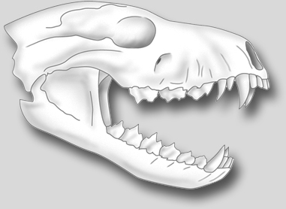 | (a) Classify this skull as an example of a herbivore, carnivore or omnivore.  Carnivore  (b) Justify your answer.  The canine teeth are very large and used for ripping and tearing; the molars are sharp and  not flat.
The following drawing shows the back teeth of a herbivore.
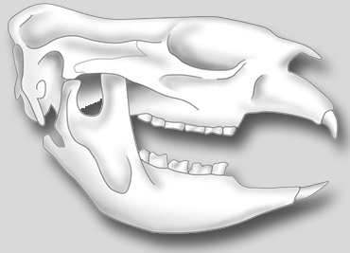 | (c) Identify the type of teeth shown and explain their function.  Molars are for grinding and chewing.
The following diagram is of a human incisor tooth.
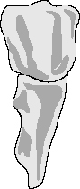 | (d) Explain the function of this tooth in our mouths.  Incisors are for biting the food.

Chemical digestion
2. Chemicals in the digestive system help to break down food nutrients into smaller particles.
Read the following text and insert the missing words.
The small intestine ............ the place where much of the chemical digestion of food takes place. Enzymes ............ the small intestine and the pancreas are involved in the digestion of starches, fats and proteins. Proteases ............ enzymes that promote protein digestion. Lipases are enzymes ............ promote fat digestion. Carbohydrases are enzymes that promote the breakdown of carbohydrates. Bile from the liver ............ also important in the chemical digestion of fats. This bile is temporarily stored ............ the gall bladder before ............ moves into the small intestine. Bile is not an enzyme. Its job is ............ emulsify the fats into tiny droplets with a large surface area. The greater surface area increases the rate ............ chemical digestion.
in
of
to
it
is
that
are
in
is

